* ***Run ‘git pull origin main’ to get latest updates’***
* ***Navigate to the libman.json and press [Ctrl] + [s] to download client-side library***

***ERD Plus***

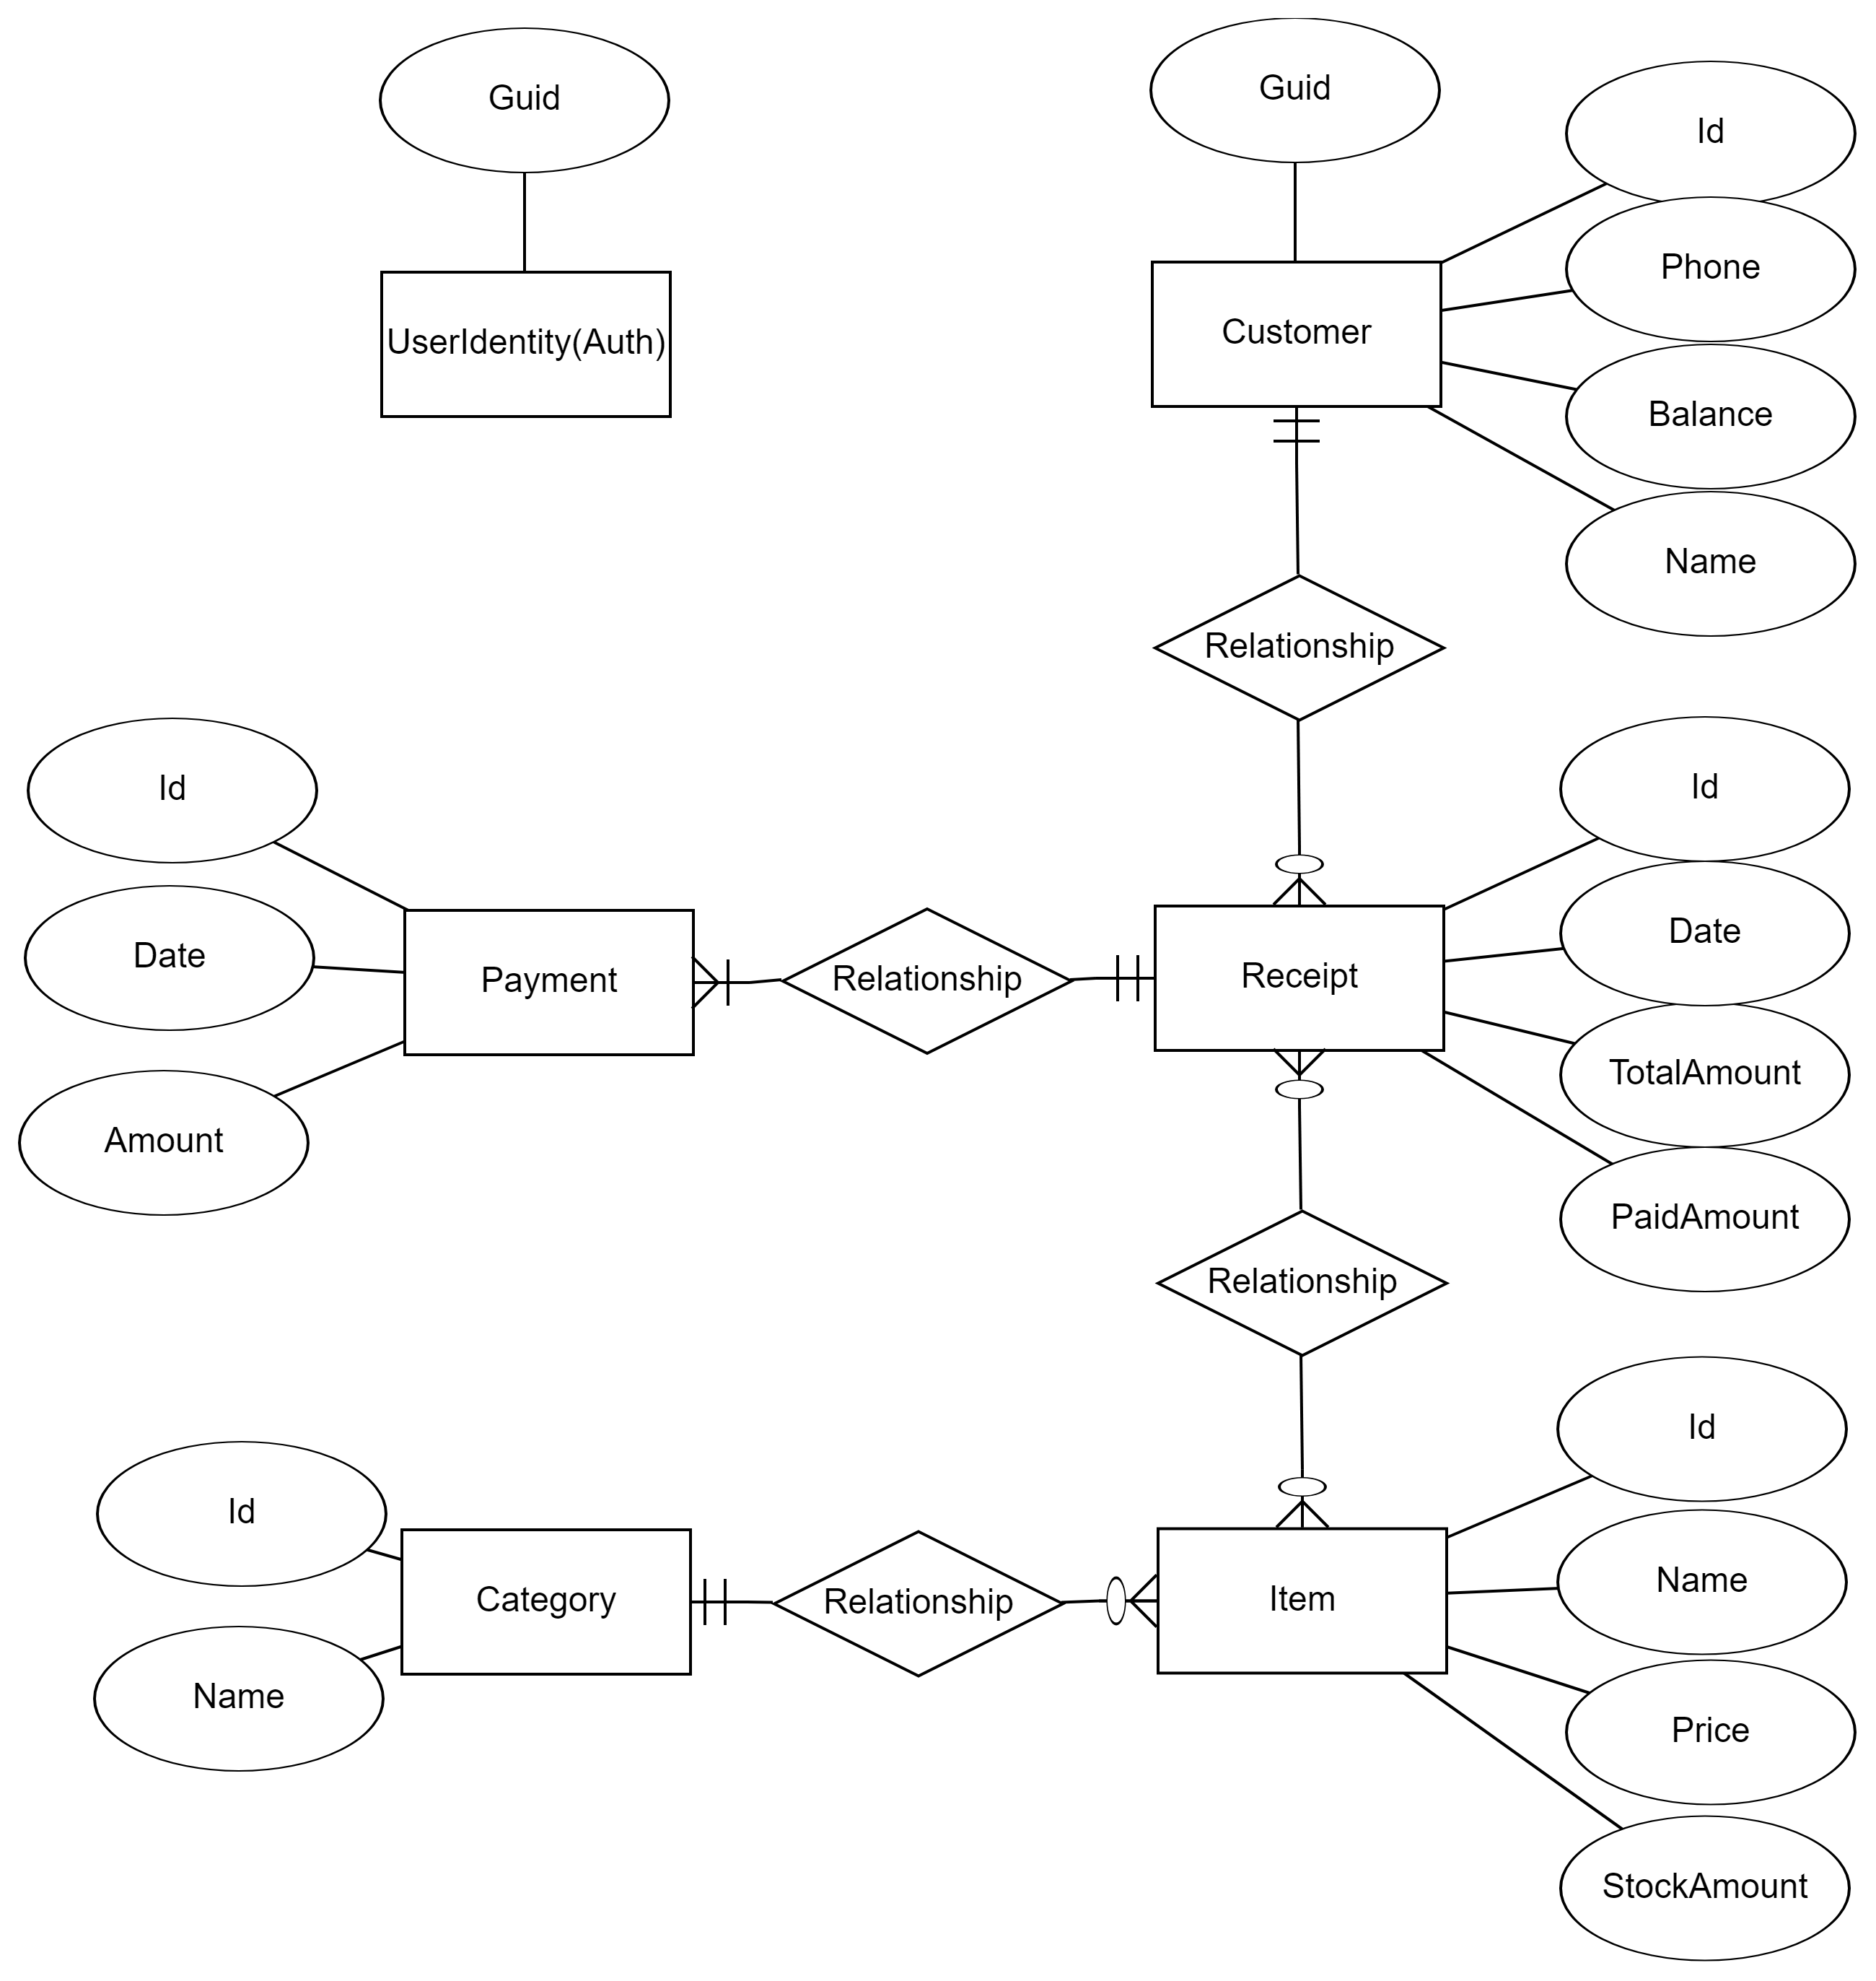

***SSMS Diagram***

